Spectroscopy using a monochromator

Introduction
You will examine two sources of light and take the atomic resonance spectra for each. One source is the sodium lamp you used with the Michelson lab, the other is a hydrogen discharge lamp. The spectra are taken using a scanning monochromator. From the hydrogen spectra your will enable you to measure the Rydberg constant. The data acquisition brings together many pieces of advanced instrumentation.

Learning goals
At the end of this lab, you should be able to:
- Explain how a scanning monochromator works.
- Estimate the scanning time for obtaining the highest resolution for your sample.
- Explain how a lockin amplifier works.
- Measure the wavelengths of the Sodium doublet (compare with previous separation measurement).
- Measure the wavelength of the four brightest lines of a Hydrogen source and also the corresponding Deuterium lines.
- Determine experimentally Rydberg’s constant (use the normal hydrogen lines, Protium).

Instrumentation
The equipment involves three main elements.

- Scanning Monochromator. This is a diffraction grating spectrometer (1800 grooves/mm holographic grating). Light enters one slit, diffracts off a grating which disperses the different colors of light, and depending on the tilt of the grating a single color makes it to the exit slit (single color=mono-chromatic).
SLIT
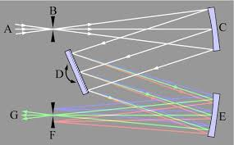
MIRROR
MIRROR
INCOMING
LIGHT
EXITING
MONOCHROMATIC LIGHT

GRATING
SLIT

The size of the adjustable slits (entry and exit) is a critical factor determining the resolution of the instrument. In general the narrower the slits, the better the resolutions (limited by other factors such as the grating ruling size and physical size of the grating). The monochromator should be used with the slits reduced to near their smallest setting (as long as there is sufficient signal). 10µm is one division on the dial.

- Detector. A detector is mounted on the exit of the monochromator. The detector is a photomultiplier tube (PMT). This device is very sensitive, and it is capable of detecting single photons. The current produced by the incoming light is measured with other instruments such as a lockin amplifier (item 3) or picoammeter. The photomultiplier requires powering in order to amplify. The setting on the power supply for the PMT is often set at -1000V. You may choose less to reduce amplification. There is a balance in voltage, alignment, and slit size (and more). You will need to make decisions (choose wisely)

- SR810 digital lockin amplifier. Think of this instrument as a very fancy voltmeter (or current meter). In our case, we will set it to read small currents and you will use it to read the output of the PMT. The readings should not be greater than about 1.00 μA. A lockin amplifier is able to detect a signal of even a few nA, or even pA. To remove any noise from your signal, an optical chopper wheel is placed before the entry slit of the monochromator (placement can matter since the goal is to reject noise, including stray light). The chopper is used to introduce a known reference frequency into the desired signal, the lockin is then able to reject noise (thermal, background light, electrical, etc.) which does not have that same frequency. The chopper may be set at roughly a few hundred Hz (as long as not a multiple of 60Hz line noise), from about 270-280Hz.

The operation of a lock-in amplifier relies on the orthogonality of sinusoidal functions. Specifically, when a sinusoidal function of frequency f₁ is multiplied by another sinusoidal function of frequency f₂ (different from f₁) and integrated over a time much longer than the period of the two functions, the result is zero. Instead, when f₁ is equal to f₂ and the two functions are in phase the average value is equal to half of the product of the amplitudes.
In essence, a lock-in amplifier takes the input signal, multiplies it by the reference signal (provided by the chopper), and integrates it over a specified time, usually on the order of milliseconds to a few seconds (we choose the time constant). The resulting signal is a signal, where the contribution from any signal that is not at the same frequency as the reference signal is attenuated close to zero.

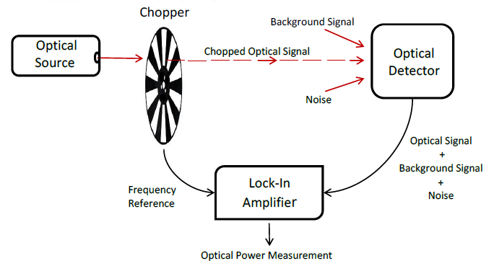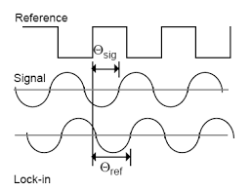

Experimental setup and procedures

Most of these settings have been already done for you, but you should know about it.
- Both lamps (Sodium and Hydrogen—NEW DEUTERIUM PLUS HYDROGEN LAMP) are set at fixed positions on the table. Do not move them, not even a hair. A magnetic base and a mirror will be used to switch from the one light source to the other.
- A lens is set up between the monochromator and the lamp(S). It is selected to be roughly the correct focal length for the instrument. This means that an input angle for the light matches the instrument to fill the diffraction grating inside the monochromator. Over filling the grating dumps light inside the instrument which scatters and gives background signal (noise). Under filling the grating uses fewer diffraction grooves and hence gives broader diffraction maximums, hence less resolution.
- Slit size. The width of the slits is controlled with a micrometer. A reading of zero in the micrometer means 3 microns width, since the sharp-edged slits do not close on themselves all the way to prevent damage. Each mark on the micrometer represents 10 microns. So, five of the smallest markings opens the slits to 50 microns (plus the 3 which may be roughly ignored). Note that such micrometer devices have offsets (non-perfect zero readings) so you may need to adjust the slits to see (observe signal) when they start opening. We will be using from ~10 to 50µm setting on both the entry and exit slit. Setting the slits at a smaller width than ~10-50 microns gives us about the highest resolution for our instrument, however very little light gets through at such settings. One needs to carefully balance instrument settings to obtain good spectra.
Also note, that uneven settings on the slit size may be noticeable on your scans. You may consult with other courses (Computational) regarding the effect of convolution of the slit image on the grating pattern.

Note, we need high resolution (narrow slits) to resolve the deuterium from protium peaks!!!! You all are the test case for this (I’ve checked and can resolve the lines)!!!!! So can you!!!!!!!!

How to obtain spectra from the monochromator?

The data you are given by the monochromator scan is “intensity vs wavelength”. The intensity is read as a current output from the photomultiplier tube recorded via the lockin amplifier.

The monochromator is controlled by a computer. The scan settings are introduced in a python program installed in the computer desktop. Once your scans are taken, you should save your files to a flash /thumb drive via USB (there is no internet connection in this computer) so that you can analyze later. The files are saved to the desktop by default in a *.csv or *.txt file. The intensity will be listed as “current”. Tools (movable cursor/measuring tools on the plot) within the software ORIGIN make some of the analysis very easy. Do not leave your data files on the lab computer.

Where and how fast should we scan?

Like any other instrument, we need to check that “zero” is really “zero” and there is not an offset in the wavelength of the measurements. We will set a first scan from -0.500 nm to 0.500 nm. We should see a peak corresponding to the zeroth order reflection reaching the exit slit (like the zeroth-order reflection on Schawlow’s ruler). If this peak is not at zero (it is not!!), then there is an offset on the readout you will need to account for in all your measurements. This offset must be measured separately for the sodium and hydrogen sources (since their respective geometries and positionings may change the offset).

We also need to set the speed of the scan, which is how often you collect a wavelength data pair as the instrument scans the wavelengths. The data interval has an indirect effect on spectral resolution in that too few data points will cause the spectrum to be distorted, whereas too many data points will cause the spectrum to take a long time to scan. The data acquisition interval should always be less than the slit width setting (many samples within one resolution interval).

It is possible to select scan parameters that don’t achieve optimum results. Consider the three parameters---scan rate, time constant, and resolution. The sample rate of the software is 10 samples per second. If we scan though a sharp spectral feature so fast that we have no data point inside that feature (we pass it in less than a tenth of a second), then we need to slow down the scan speed.

Likewise, the best possible monochromator resolution is about 0.05nm—with narrow slits. So, whatever scan rate I select should sample at least several data points during the time it takes to move through 0.05nm (oversampling is better than undersampling).

The lockin Time constant is kind of similar to an RC time constant. It smooths out the signal over a selectable period of time. In general we want to make sure that at least one data point is taken during any time constant---here we have a fixed 0.10seconds selected for you. This typically works, but you may want to change this (Deuterium /Protium resolution may be tough)

For example: If I scan through 0.1nm/second (6nm/min), but have a time constant of 20seconds, then the monochromator will move 2.00nm during one time constant. We will no longer be able to clearly resolve at the best response of the monochromator—since we are scanning too fast. You want to select parameters that make best use of the instruments.

Amplitude of your signal. Although we are not interested in the amplitude of the peaks, just in their positions, we need to set an “optimal” signal in order to get better results. We need the peaks to be “larger” than any background noise, but not large enough to saturate the reading (your signal will have the peak chopped off ---you don’t want to see the red overload light on during your scan). For that, there are two adjustments we can do:
- Adjust the sensitivity scale on the lock in amplifier.
- Increase/decrease the voltage on the PMT power supply. Do not set it over 1200 V.
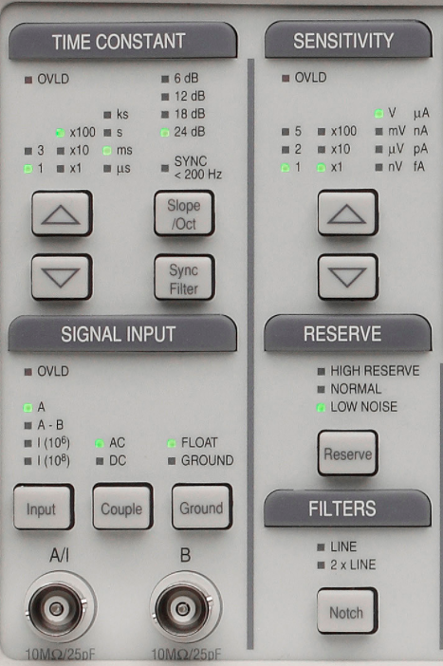
Lock in amplifier settings:
- SIGNAL INPUT: I (10⁶); DC; FLOAT
- RESERVE: HIGH RESERVE
- FILTERS: LINE; 2X LINE
- TIME CONSTANT: 1; x100; ms; 24dB
- SENSITIVITY: you would have to adjust this, so your signal is almost full scale on the lock in without saturating (lights will turn solid red).
- Once you have signal, you should click on AUTO PHASE (not in the picture).

A scan sheet with the parameters needed for these experiments will be supplied.
Analysis

We will regiment the scans and recommended settings for each scan and for all instruments to acquire data for. You need to scan
- The zero-offset wavelength of the monochromator (one for each lamp).
- The two bright yellow lines in Sodium.
- The three of the four visible Balmer’s series lines in Hydrogen (~656, 486, 434, 410nm).
  - You may or may not be able to observe 410nm—not easily detectable to our PMT.
  - On your scans you should be able to see the two peaks for both Deuterium and Protium. You’ll report peak positions for both!!!!
- Using the information from the Balmer’s lines (Protium), you should be able to determine the Rydberg’s constant. The Balmer series has transitions from upper states (n) to a final state of 2. (Eq 11.2 page 126, Essentials of Modern Physics, T.R. Sandin). You can look up in any reference you wish.

- For each spectral feature you analyze you will make a graph which you can analyze to determine a peak wavelength and a line width. This width is a convolution of the instrument resolution and the true width of the spectral feature. For example, the width of a HeNe laser line (light scattered off a note card into the monochromator) should appear to be a delta function with very narrow width but will appear to be about 0.05 to 0.1 nm wide due to the limitations of the instrument resolution. Several factors influence the width and the intensity of spectral features. To measure the line width, we will measure the “FWHM”—Full Width Half Maximum. Go to the peak, find the maximum, and then go to wavelengths that are half the maximum and subtract.

The uncertainty on the peak position determination (measurement) will depend on several factors but are largely dependent on the noisiness of data you observe for each plot. You will need to actually make an estimate of how well a peak position can be determined by observing the noise at/near each peak. This is your call, but any reasonable person should be able to make a similar call on the uncertainty. NOTE: THE FWHM IS NOT THE UNCERTAINTY.

Lab procedure

- Very carefully turn on the hydrogen lamp. Let it warm-up for a few minutes.
- Check the light is hitting the monochromator slits
- Turn on the lock in amplifier
- Turn on the power supply for the photomultiplier detector
- Turn on the monochromator
- Turn off the room lights (maybe left one on).
- Adjust sensitivity in the lock in and/or voltage for the PMT
- Run the python file and complete the required scans.
- Set the mirror to use the sodium lamp. Let it warm-up for a few minutes.
- Repeat
- Ensure you dial the PMT voltage to zero
- Turn off all the instruments

Tasks:
- Make individual plots for each of the four (or three) hydrogen lines. Include peak for Deuterium and Protium and separation. One plot for sodium will do (both peak values and separation). ANY WAVELENGTH YOU REPORT TO ME HAS ACCOUNTED FOR ZERO OFFSET.
- For Protium, fit the 4 (or 3) peak wavelengths vs. 1/n^2 to determine the Rydberg constant
- Report a table of peaks for Deuterium, Protium, and fwhm’s for each, likewise sodium
- You should compare all results with knowns.
- You’ll need to make estimates of uncertainties from your plots (think about).

